SYNOPSIS
Title: Cattle on Roads - Enhancement of Safety (CARES)

Abstract:
Stray cattle pose a significant threat to road safety and animal welfare in India, with motor vehicle accidents causing injuries and fatalities to both humans and animals. This project proposes a comprehensive approach to enhance cattle protection on Indian National Highways (NHs). The approach involves two main components: the utilization of nylon belts with fluorescence for improved cattle visibility during night-time and the integration of a sensor system that detects accidents and communicates with veterinary services. Through the implementation of these innovative measures, the project aims to reduce accidents involving cattle and promote the well-being of both animals and humans.

Problem:
India's roads are plagued by the presence of over 5 million stray cattle, contributing to road accidents and posing risks to both human safety and agricultural productivity. This project addresses the urgent need for cattle protection by introducing a holistic strategy that leverages technology and innovative solutions. Motor vehicle accidents involving stray cattle are a pressing concern, particularly on National Highways (NHs). Statistics from major Indian cities indicate that cows alone account for 28.4% of road accidents involving stray animals.

Solution:
To mitigate this issue, this project proposes the integration of nylon belts with fluorescence. These belts serve a dual purpose – enhancing the visibility of cattle to drivers, especially in low-light conditions, and ensuring the comfort and well-being of the animals. This novel approach not only reduces the chances of accidents but also minimizes the stress and discomfort caused by conventional restraint methods.
To further enhance the safety of cattle, a sensor system is recommended. This system employs accelerometers, gyroscopes, and GPS technology to detect sudden changes in the animals' movements that could be indicative of accidents. Upon detecting such events, the sensor system promptly alerts nearby veterinary services, providing them with the animal's location for swift medical intervention. This proactive approach not only aids in reducing suffering but also contributes to the efficiency of emergency response.
The primary objective of this project is to quantify the reduction in motor vehicle accidents involving cattle on NHs, thereby measuring the efficacy of the proposed safety measures. Additionally, the project aims to evaluate the efficiency of the sensor system in detecting and communicating health-related incidents to veterinary services.

Working of model:
The device will be powered with the battery fitted inside it and it can be recharged using flexible solar panel mounted on the collar itself.
This system works according to broadly 3 cases.
Case I
The cattle is just existing without and threat of being hit. The temp. sensor, Spo2 sensor, heart rate sensor and GPS will keep monitoring the cattle’s vitals and transmit the data to HQ every 5 mins. This will help us to keep track of its position and health, possibly preventing spread of any diseases if required. Moreover, the location data can be combined with Google Maps to show cattle crowding in an area. If the system detects any abnormalities in the health, it can inform the authorities for a check-up.

Case II
The cattle is standing in middle of the road and a biker is approaching. It is dark in the night time. The rider sees the reflective strip shinning and LEDs blinking from a distance and s/he manages to avoid the collision. In that case it doesn’t triggers anything else except for the things mentioned in case I.
Case III
It is the same situation as mentioned in Case II but, this time the biker fails to avoid a collision and causes an accident. The accelerometer, gyroscope and heart rate sensor will detect the collision and inform the authorities about this accident along with location of collision. After that it will keep transmitting its live location and vitals every moment instead of every 5 min till it has got medical aid. With the location of collision, authorities can save the human and if the cattle is still able to move and walks away from the location of collision, it can tracked using live location.

Material requireds:
|accelerometer MPU6050 gy521
|GPS NEO - 6M/ATGM336H
|GSM SIM 800L
|MAX30102 pulse oximeter
|RFID RC522
|Solar panel
|Wires
|Led(s)
|Reflective tape
|Collar
|Arduino Nano
|LM-35

Digram:
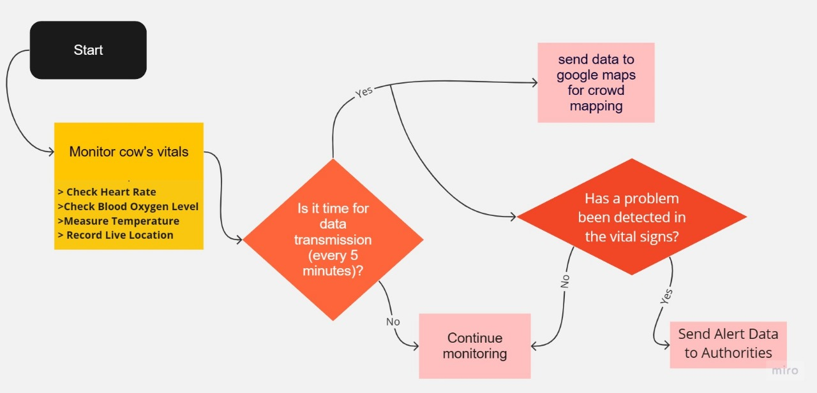
Case I

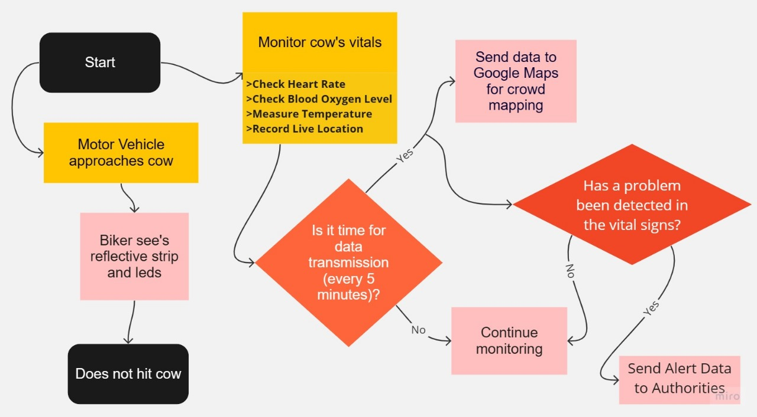
Case II
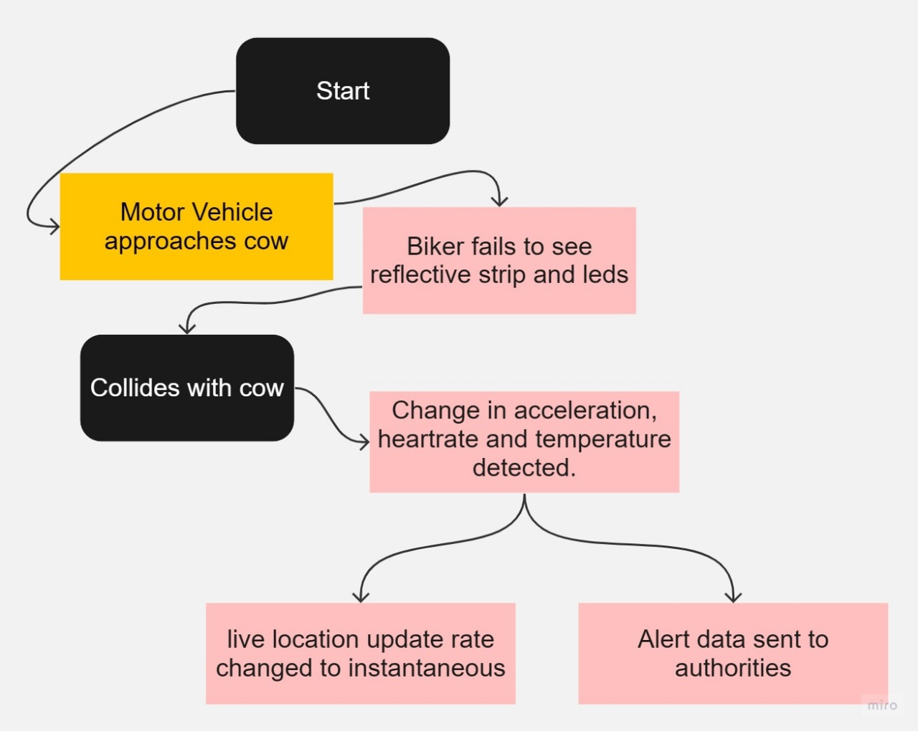
Case III

Future Development:
The successful implementation of this project could pave the way for broader applications and improvements in cattle protection on Indian roads. Future developments may include:
- The accelerometer and gps can be made into implants done
- This will reduce the bulk on the cow and further help it in free movement
- The electronics being inside the cow will mean that there is no chance of it getting thrown off due to rapid movement
- Battery efficiency can be improved

Scalability:
If proven effective, the use of nylon belts with fluorescence and sensor systems could be extended to other regions with similar challenges.

Technological Advancements:
As technology continues to evolve, more sophisticated sensors and communication methods could be integrated to enhance accuracy and responsiveness. The efficiency of the system can be further improved to make it energy efficient and lighter.

Public Awareness:
Raising awareness among drivers and the general public about the presence of cattle on roads and the importance of safe driving practices could further prevent accidents.

